Route 53

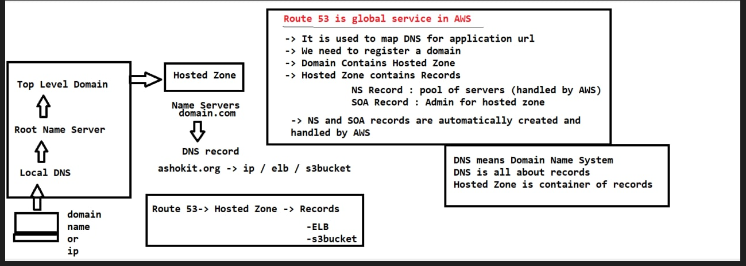

Whenever you hit the URL ur request will go to local DNS from the Local DNS it will go to Root Name Server from here it is going to Top level Domain now from this top level domain the request is going to Hosted Zone

Whenever u register a Domain their will be Hosted Zone in Hosted Zone we are having NameServers, The Name servers are mapped to our domain.com

My application will be having lengthy URL or ip address, I cannot give the people ip address/ URL to access my application so for that purpose we are going to take a domain for our application and we need to map the domain name to our application ip address or our application loadbalancer URL or our application s3 bucket URL for that pupose we are registering a domain in the AWS

Whenver u purchase a domain u are getting a hosted zone, so hosted zone is a the container of the records by default it will create 2 records

**1)NameServer record:** pool of servers will be available to handle our application requests. If one server is down another can handle that request

Nameservers are used to map the ip address to our application URL and application name to ip address

Every Domain will have multiple Nameservers

**2)SOA record:** we don’t use this directly this is for admin part of hosted zone that will be used by AWS in order to handle the request which are coming to our domain

Note: From the browser u r hitting this ashokit.com url from the url request it is gng to domain from the domain it is gng to hostedZone, this HostedZone is giving records , record is available our domain name that record is diverting to s3 bucket,s3 bucket is having a static website this static website is loading back to the our browser… this is what we have done in the LAbtask

Q: whenever u hit the facebook.com how the facebook is applicationis loading, what is happening in the facebook background

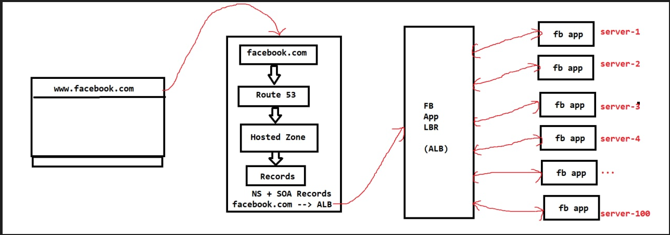

A: whatever u r hitting the url domain name facebook.com in the browser when u send a request it is going to talk to top level domain(facebook.com) that domain name registered in AWS by using Route53 so that domain will go to Route53 service-> in this Route53 service we have hosted zone the hosted zone conatins some records so there are 2 records available by default(NS record & SOA record) a;ong with those 2 records we created a custom record i.e facebook.com

Now when I create custom record what iam telling that record should be divert the traffic to facebook application loadbalancer so the DNS mapping will be available so facebook.com is mapped to LBR this LoadBaancer(LBR) is having multiple instances(facebook servers) all people will be using, huge traffic will be coming to this application that’s y multiple servers will be available to handle all those servers are called instances

So multiple instances we are going to take in this ec2 instances we are going to install our webservers and we are going to deploy our application so in realtime our application will be running in multiple servers